Agronomy Field Trials ‘08
To determine the effect MorindaGro has on corn silage quality and production a field trial was conducted in northern Nevada during the summer of 2008. MorindaGro was applied two times at the rate of 1.5qt/ac or 3.0qt/ac to irrigated corn. It was applied when the corn was approximately 12” and again when the corn was approximately 24” tall. Corn was cut in early fall as corn silage. Random samples of the control, 1.5qt/ac and 3.0qt/ac was taken during cutting. These samples were submitted to Dairy One at Ithaca, NY for proximate analysis. Results from part of the analysis are presented in accompanying graphs.
Tons per acre were increased with the 3.0qt/ac compared to control or 1.5qt/ac.
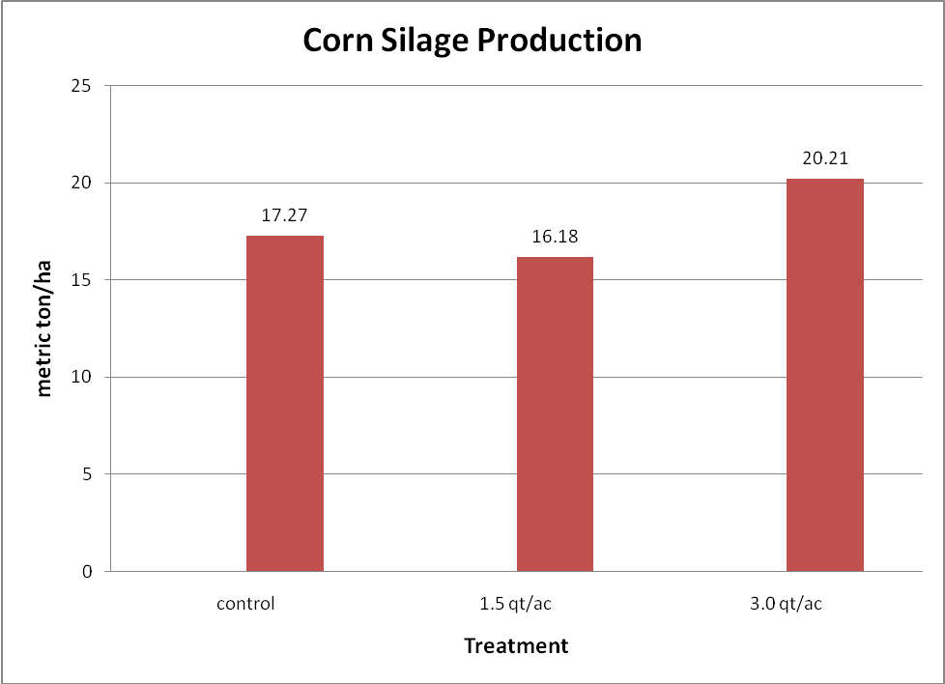
Crude protein was depressed at both treatement levels. This may be due to sampling error. Since both the 1.5qt/ac and 3.0qt/ac resulted in the same protein level, sampling error is more likely the cause.
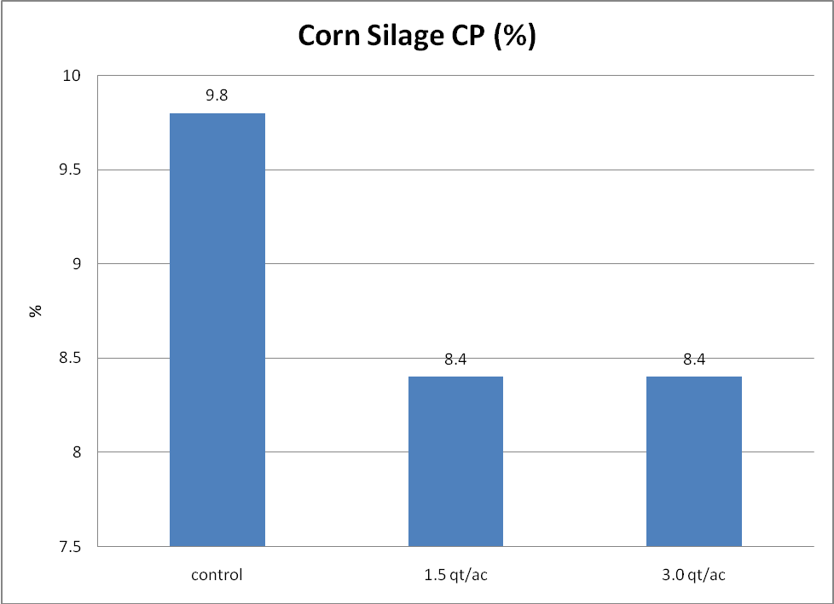
Total Digestible Nutrients is a measure of energy. The control and 3.0qt/ac had a great TDN content than the 1.5qt/ac.
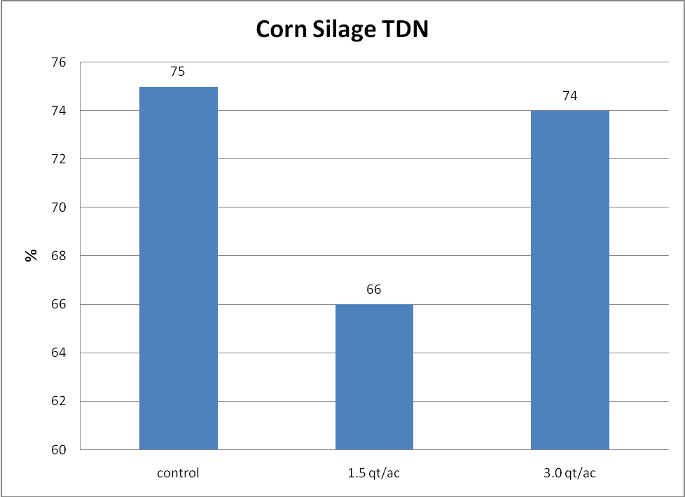

To determine the effect of MorindaGro on alfalfa hay nutrient profile a sister study to the corn study was conducted. MorindaGro was applied at 1.0qt/ac and 2.0qt/ac but only one time. It was applied when the plants were approximately 6” tall, immediately after a previous cutting of hay. It was applied via a mechanical sprayer similar to the corn trial. The alfalfa was cut for hay in the pre-bloom stage. Again, samples were submitted to Dairy One for analysis. Results from part of these analyses are also presented in accompanying graphs.
Crude protein was increased by both levels of MorindaGro. There was a 9% and 7% advantage to using MorindaGro at 1.0 and 2.0qt/ac, respectively. There was essentially no difference between the treatment groups.
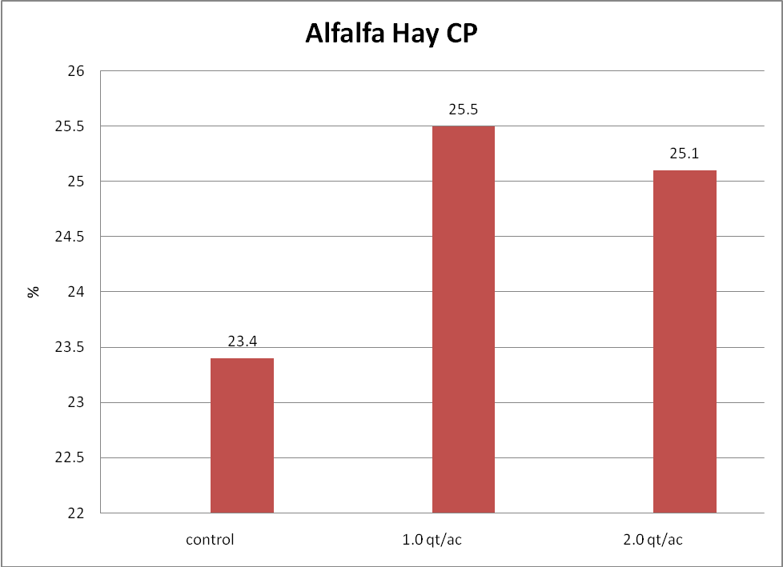
Relative Feed Value (RFV) is an index for ranking forages based on digestibility and intake potential. RFV is calculated from ADF and NDF. A RFV of 100 is considered the average score and represents alfalfa hay containing 41% ADF and 53% NDF on a dry matter basis. The higher the RFV, the better the quality of the hay. Both levels treatment represent a 17.6% and 14.1% improvement in RFV.
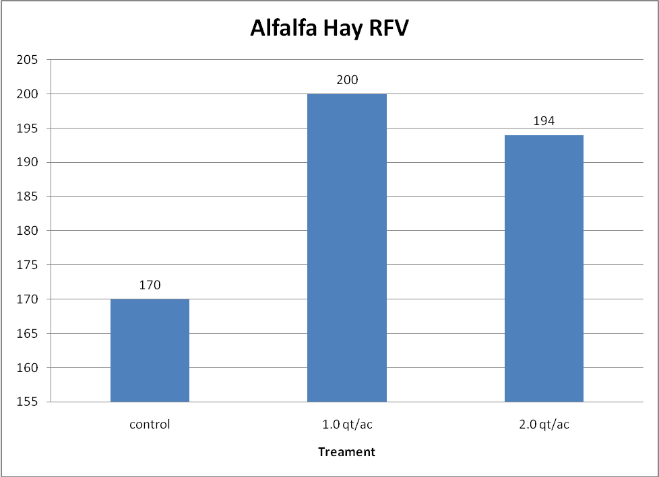
Digestible energy was also increased by applying MorindaGro to the alfalfa during early growth. DE was 5.8% and 3.8% higher with the 1.0 and 2.0qt/ac applications, respectively.
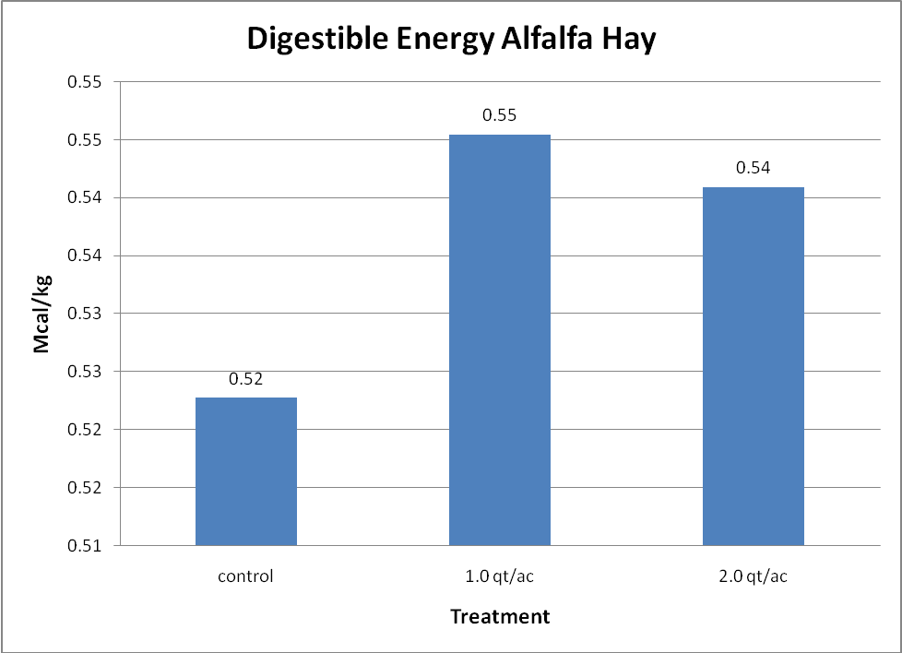
A field trial was conducted in the Texas panhandle to determine the effect of MorindaGro on Tift 85 Bermuda grass nutrient content and production. MorindaGro was applied one time in a mechanical sprayer at the rate of 1.0qt/ac mixed in 10 gal of water. It was applied 7d after a previous hay cutting. The plants were approximately 6” tall. As before, samples were sent to Dairy One and results are included in accompanying graphs.
The relative feeding value of Tift 85 Bermuda grass was increased by 17.7% with a single application of MorindaGro. This is very similar to the results in alfalfa where 1.0qt/ac improved RFV by 17.6%.
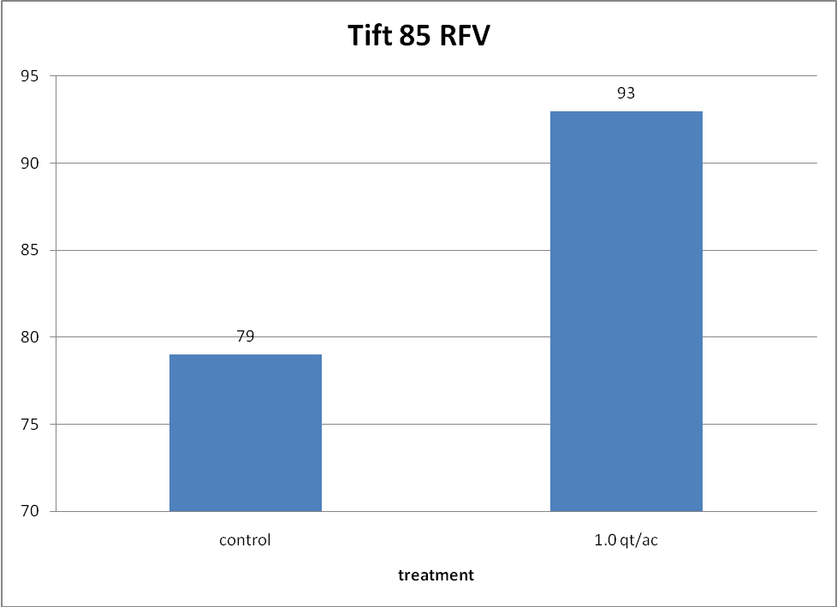
Crude protein was increased 28.9% with 1.0qt/ac of MorindaGro. This is much greater than the increase in alfalfa where the crude protein was initally much higher in both the control and treated samples. It may beas the initial content is higher, incremental improvement may be more challenging.
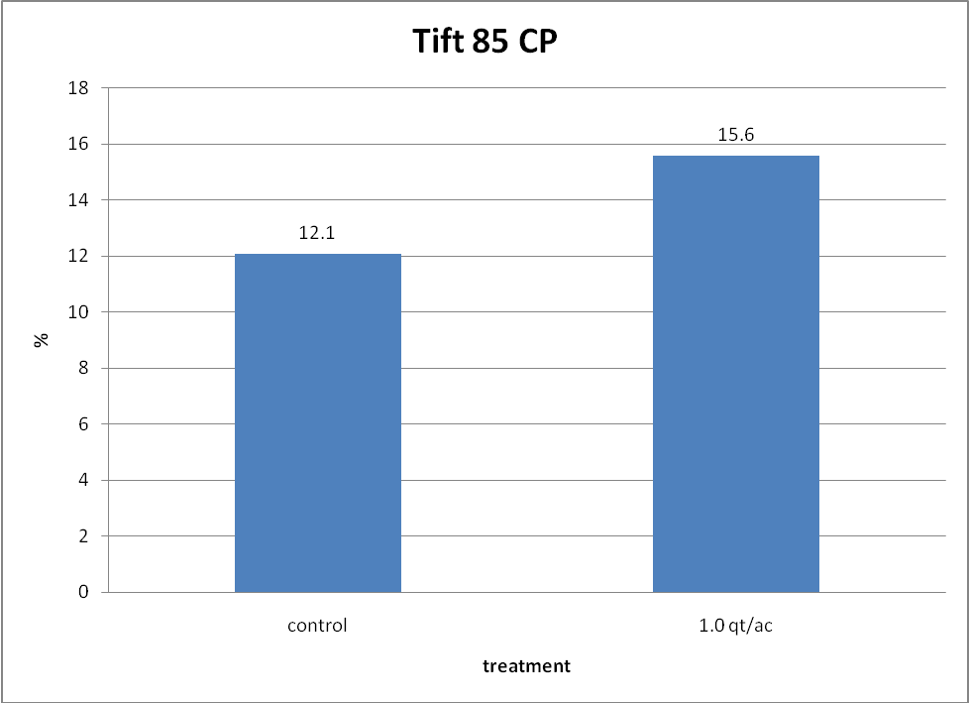
Digestible energy followed other nutrient measurements in this tial sample. It was increased 7.5% by the addition of a single application of 1.0qt/ac of MorindaGro. This is higher than that seen in alfalfa, but alfalfa has a much greater DE content than does most grasses.
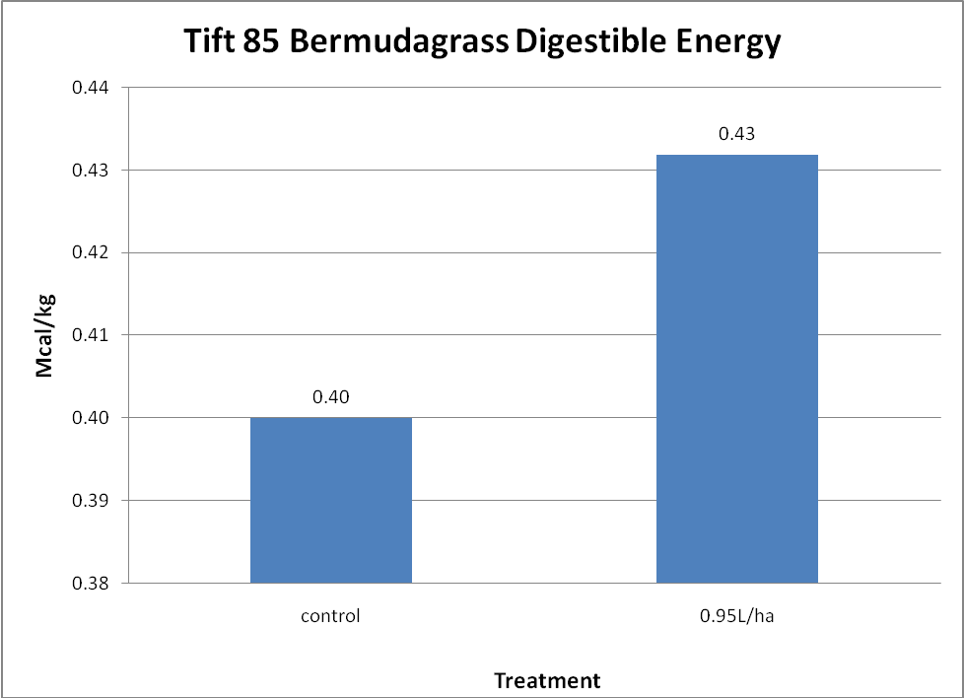
In addition to increased nutritive value, the addition of 1.0qt/ac of MorindaGro to Tift 85 Bermuda grass, production per acre increased by 50.3%. 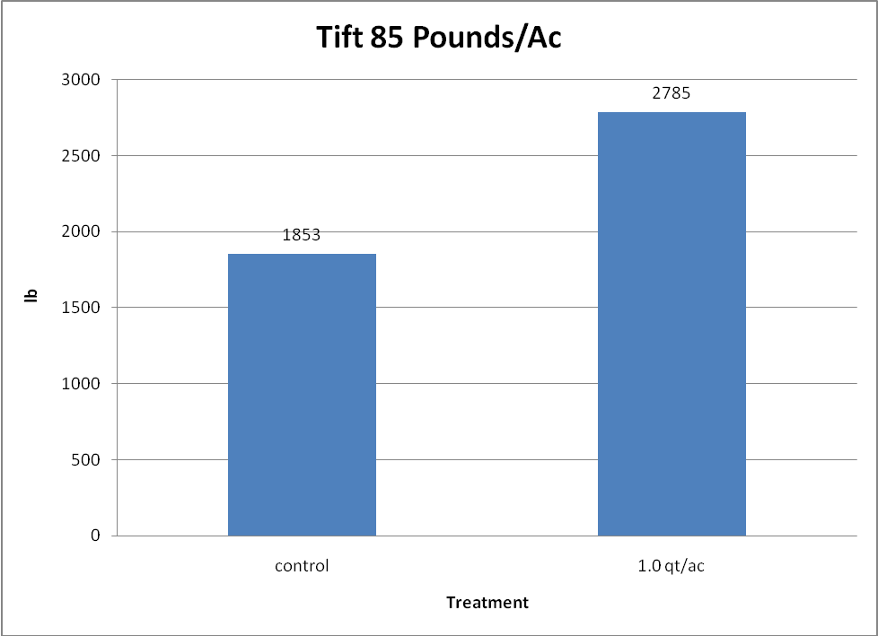
In summary, the application of MorindaGro to alfalfa and Tift 85 Bermuda grass improves nutrient content of these forages.
- Crude protein is increased. The magnitude of change may be influenced by the initial content of the plant, e.g. legume as compared to grass.
- Digestible energy is also improved in both alfalfa and Tift 85 Bermuda grass. Additional MorindaGro does not necessarily translate into increased DE content.
- Relative Feeding Value is influenced by MorindaGro treatment. In general this showed an overall improvement in the value of the both alfalfa and Tift 85 Bermuda grass for meeting the nutritive needs of ruminants and non-ruminant herbivores.
- Production was increased in Tift 85 Bermuda grass with the addition of MorindaGro.
- The results in the corn silage are less understood than the forage work. MorindaGro was applied twice during the growing season. This resulted in putting 3.0qt/ac and 6.0qt/ac on the crop. Results from animal trials have demonstrated a point of diminishing return with excessive amounts of M. citrifolia. The other factor apparent in this corn field was the extreme variation in mature plant size. This may have been attributable to soil conditions, fertilizer application error, or lack of adequate water on certain parts of the field.

_____________________________
Richard G. Godbee, Ph.D., PAS
Director Research and Development
richardgodbee@morinda.com

